Public Pension Plan Mortality Study – Request for Participation

The Society of Actuaries (SOA) is an independent nonprofit organization that provides actuaries with the education, research and technical skills to help improve decision making for organizations that use actuarial services.

In October 2014, the SOA released the RP-2014 Mortality Tables Report that presented updated sets of private sector base mortality rates designed to supersede those in the RP-2000 Report. Although some public pension plan data was received for the study that led to the development of the RP-2014 Mortality Tables, that data was ultimately excluded for two primary reasons: i) the scope of the project was to develop updated mortality tables for the private sector, and ii) the statistically significant differences between the private sector and public sector results.

Since the release of the RP-2014 Mortality Tables Report, a number of actuaries have requested that the SOA perform an additional study to determine whether separate sets of mortality tables would be more appropriate for public sector retirement programs. In response, the Retirement Plans Experience Committee (RPEC) of the Society of Actuaries is undertaking a new, separate study of public sector mortality experience. RPEC anticipates completing the data submission and validation phases of this project by early 2016, and it expects to present preliminary results by September 2017.

We are requesting your participation in this study and ask that you submit data for the plans in your system. The deadline for data submission is November 20, 2015. The more data we receive, the more robust our analysis will be, so your system’s participation is important. More specific information about the data being requested and the overall data submission process can be found on the SOA web site.

All data submitted, as well as the identities of the contributors, will be kept confidential. Only the data compiler and SOA staff will have access to the data that you submit. There will be a confidentiality agreement with the data compiler in this regard. The data will be aggregated across all plans and contributors before it is shared outside of the data compiler and SOA staff and it will be used only for purposes of this mortality study and the potential creation of new mortality tables.

Please confirm by August 31, 2015 whether your system will participate in this study by contacting Erika Schulty of the Society of Actuaries at eschulty@soa.org or 847-706-3519. If you choose to participate, please provide the names of all plans for which you intend to contribute data and the best person to serve as the ongoing contact. If you wish, you may contact Erika with any questions regarding this effort. As necessary, they will be addressed by me and the rest of RPEC.

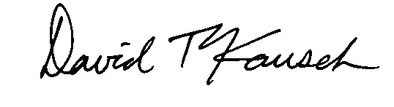

David T. Kausch, FSA, FCA, EA, MAAA, Chair
Retirement Plans Experience Committee
August 2015

